OWASP Top 10 Insecure Data Handling - Lab Report

Date: 26/06/2026
Difficulty: Easy
Category: OWASP Top 10
Platform: TryHackMe

Overview

This lab focuses on insecure data handling from OWASP’s Top 10 list and each vulnerability is described and details about how to prevent them are also given to help reduce the risk of these vulnerabilities.

2. What I did

A04: Cryptographic Failures happen when sensitive data is not protected due to a lack of encryption, poor implementation or bad security measures. Things like using weak algorithms, storing passwords without hashing or exposing encryption keys are examples of this. To prevent this, you should use strong, modern algorithms and implement them properly, sensitive data like passwords should be hashed and use trusted algorithms to encrypt data. A practical example of this is shown below where I am given the first 3 values for the key and I read the rules which stated it has to be letters and numbers so I knew it would be KEY + a number from 0-9 so I tried KEY1 and it worked which was a very weak passkey and it gave me access to the sensitive notes.
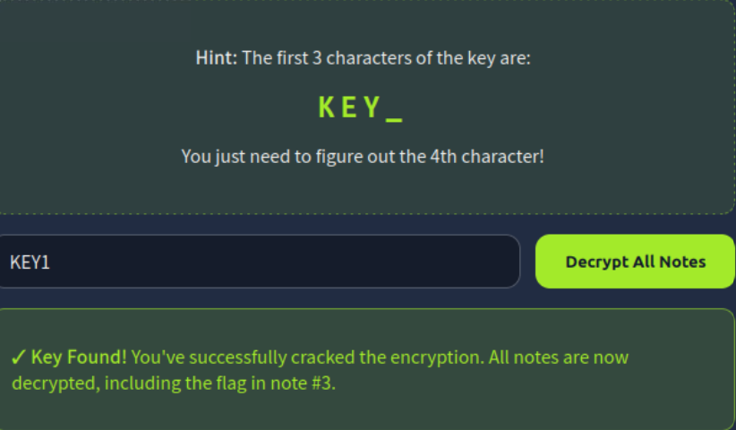

A05: Injection happens when an application receives user input and mishandles it so instead of processing the input securely, the application sends it straight to a system that can run commands or queries such as SQL Injection for SQL databases. SQL Injection happens when the application fails to sanitise user input and instead uses it to build the query. To prevent this, user input should always be treated as untrusted and validated, use prepared statements and parameterised queries instead of building queries through string concatenation and use safe API’s and processes that do
not invoke the shell.

A08: Software or Data Integrity Failures happen when an application needs code, updates or data it assumes are safe without determining their integrity or where they came from. This could be loading scripts or config files from untrusted sources, trusting software updates without verification or using binaries or JSON files without confirming if they have been altered or not. This can be prevented by not assuming that code or updates are safe and trusted without verifying first by using checksums for updates and making sure that only trusted sources can modify important applications or systems.

3. What I’ve learned

- OWASP Insecure Data Handling examples
- What each vulnerability is and how to mitigate them

